**AWS CAPSTONE PROJECT – SCREENSHOT FILE**

**Step-1:** Set up a word press instance to publish blogs using AWS Cloud Formation.

Creating a key-pair on N.Virginia region

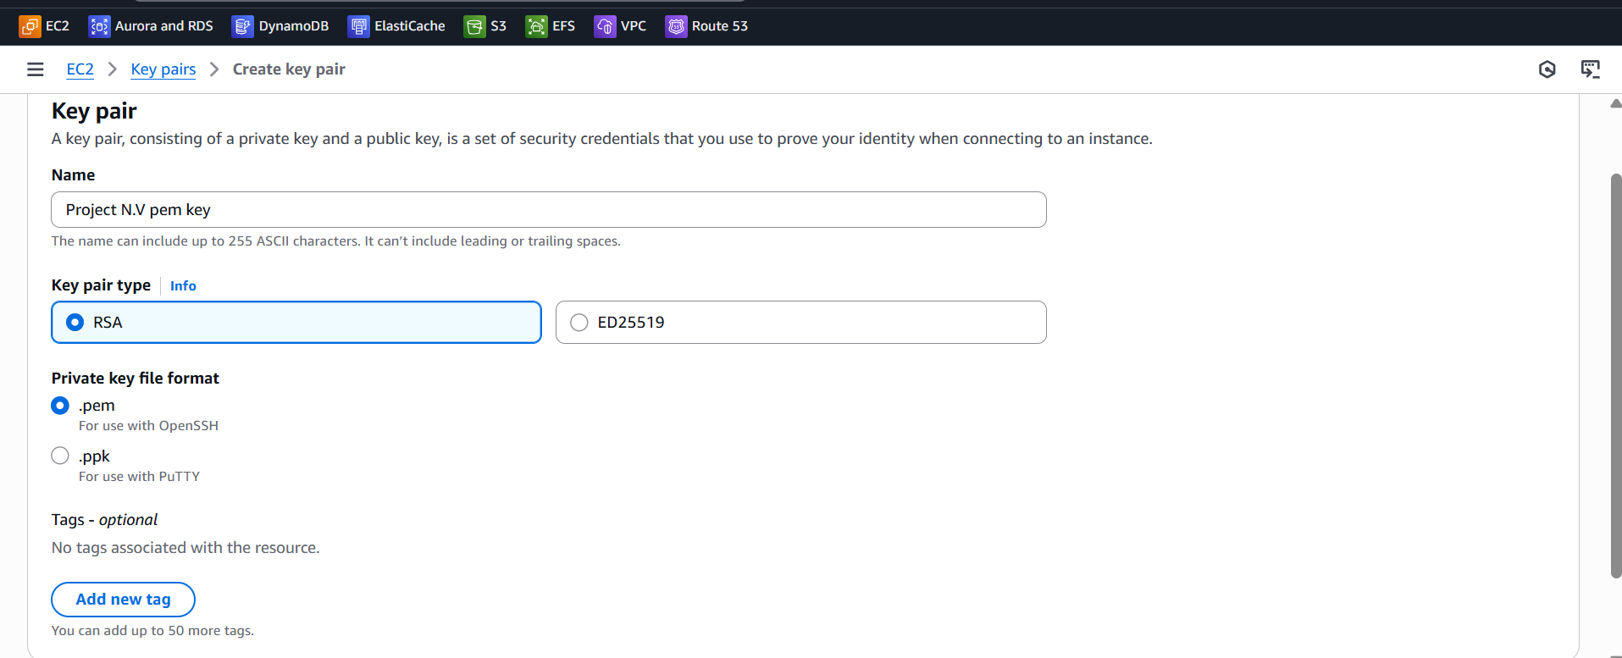

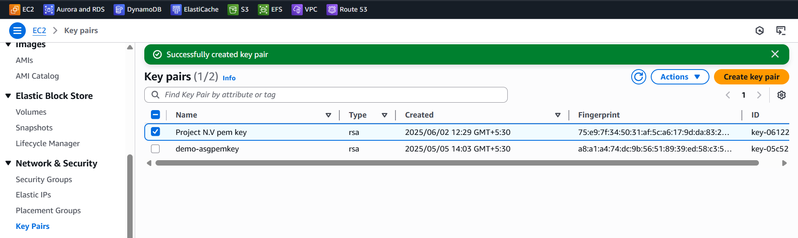

Creating a stack on Cloud Formation:

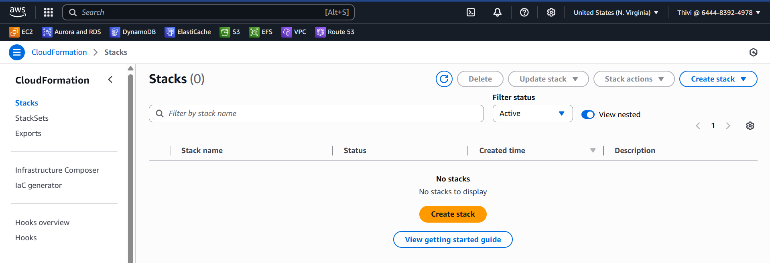

Choose the wordpress instance template

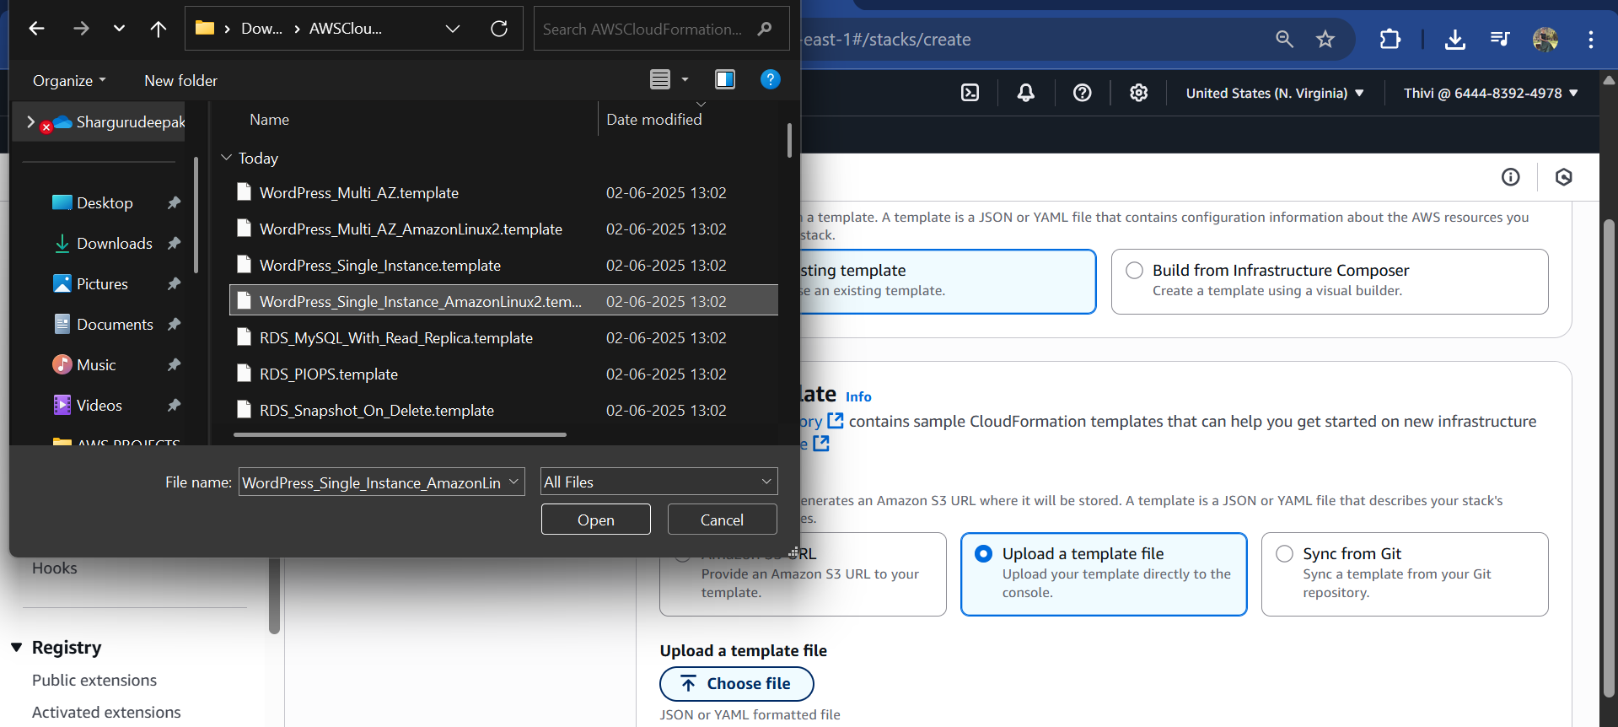

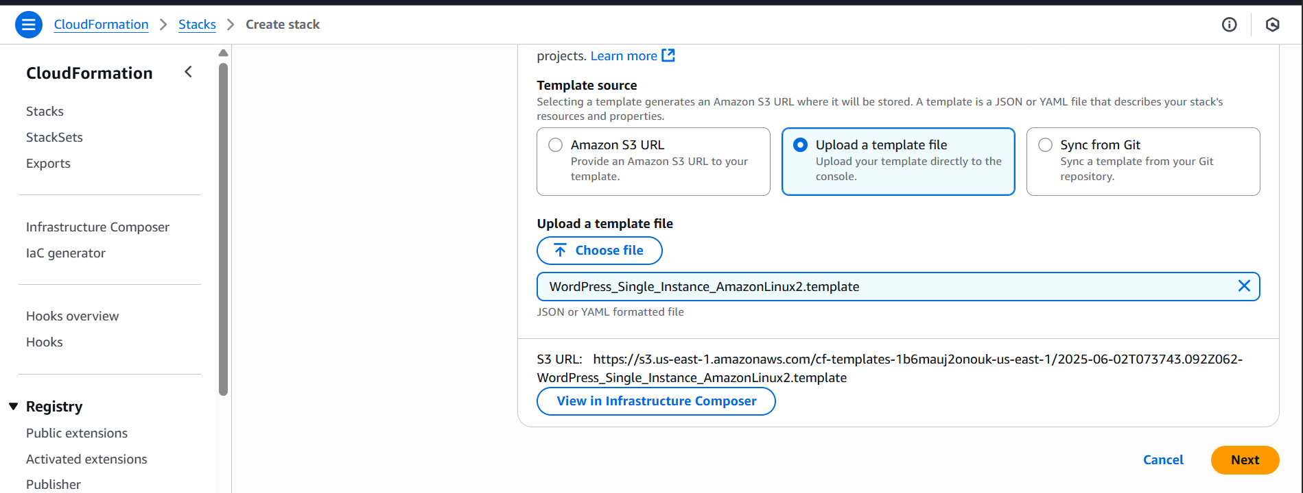

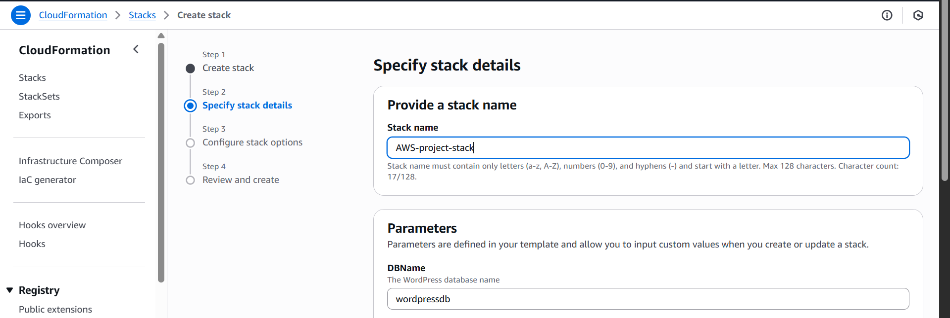

Set up the DBPassword : password

DBRootPassword : password

DBUser : admin

Instance type : t3.large

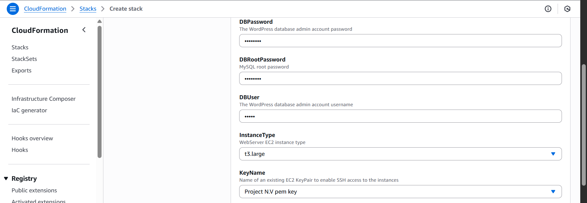

Let the remaining configuration to default

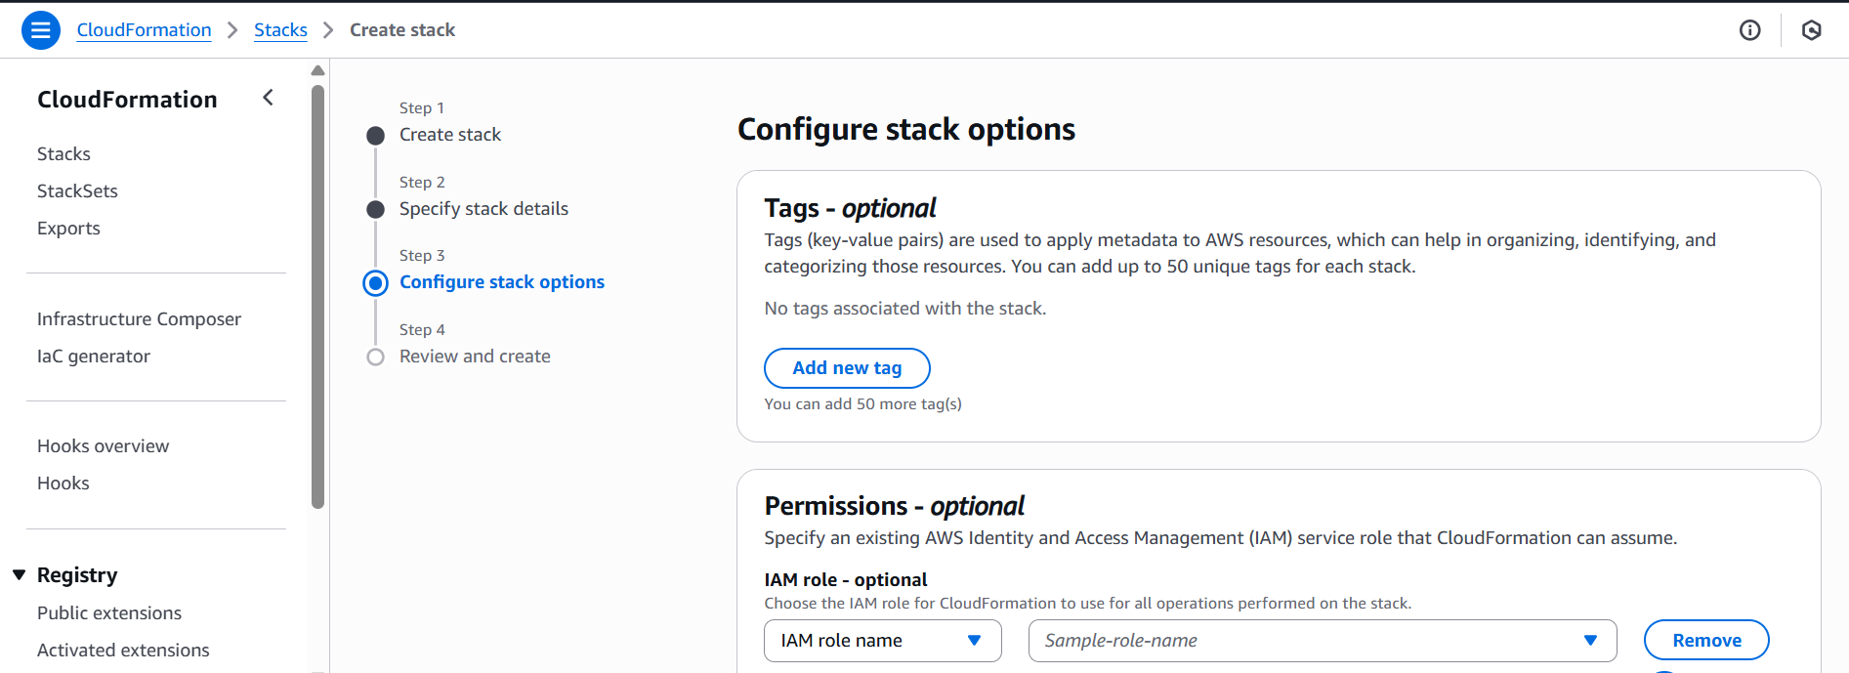

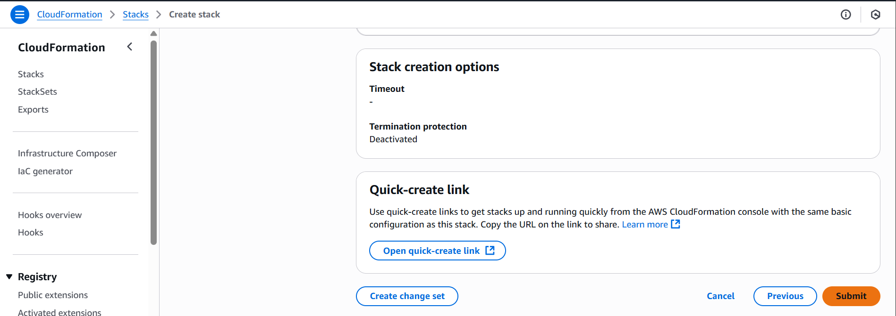

Submit and the Stack will be created.

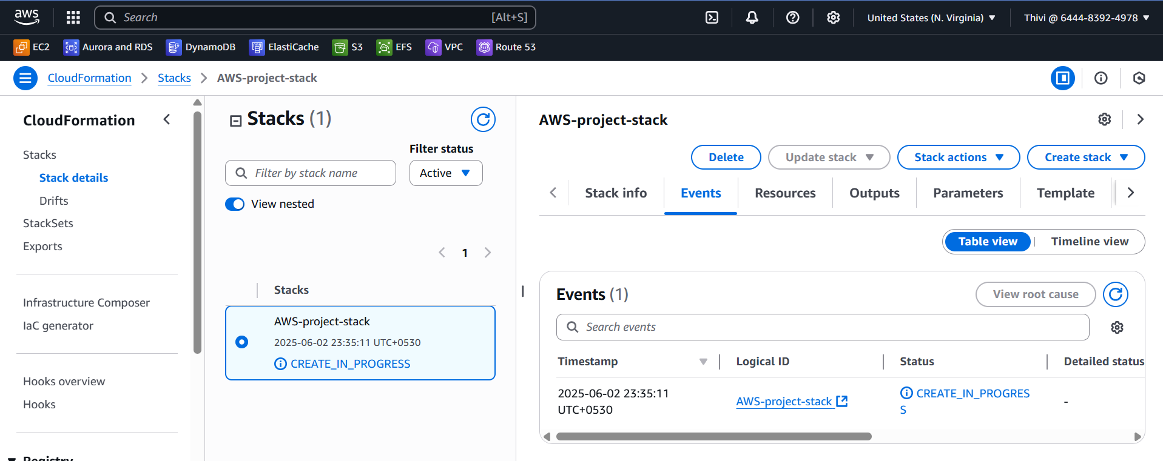

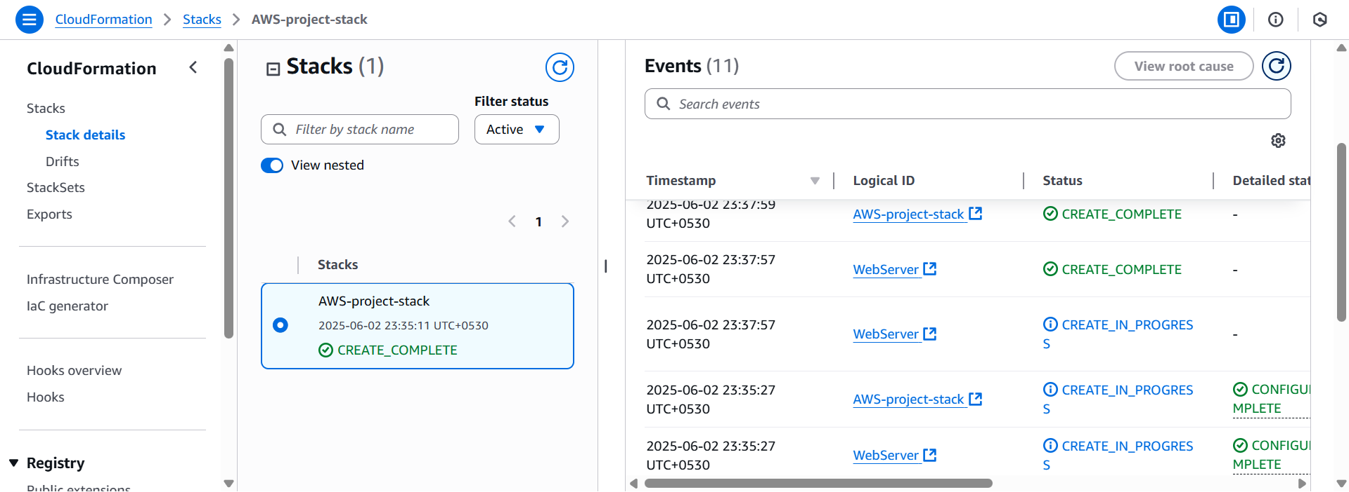

The instance has been launched according to the template.

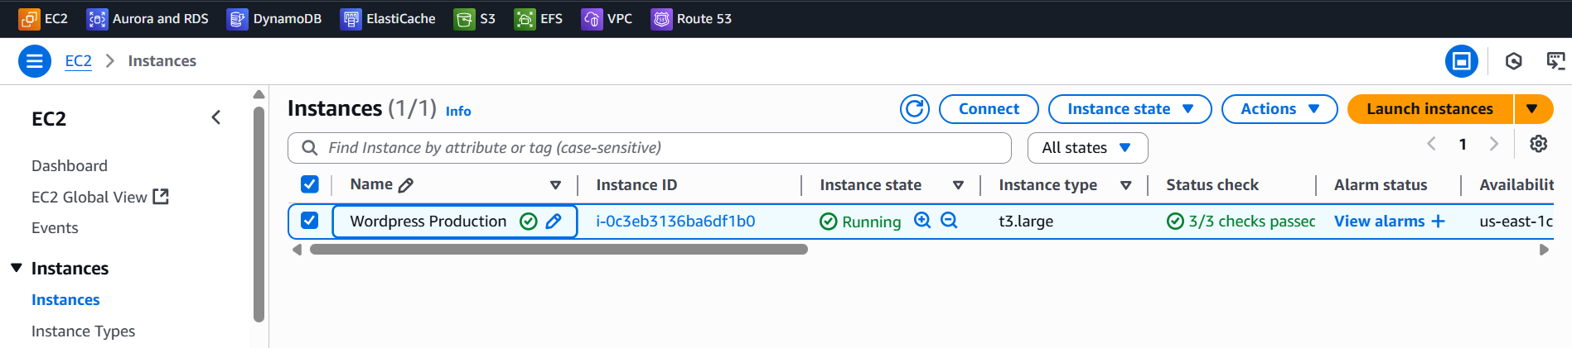

Copy the public IP/wordpress and paste on the browser to check if the server is live.

The server is live with the wordpress, provide the details and install wordpress

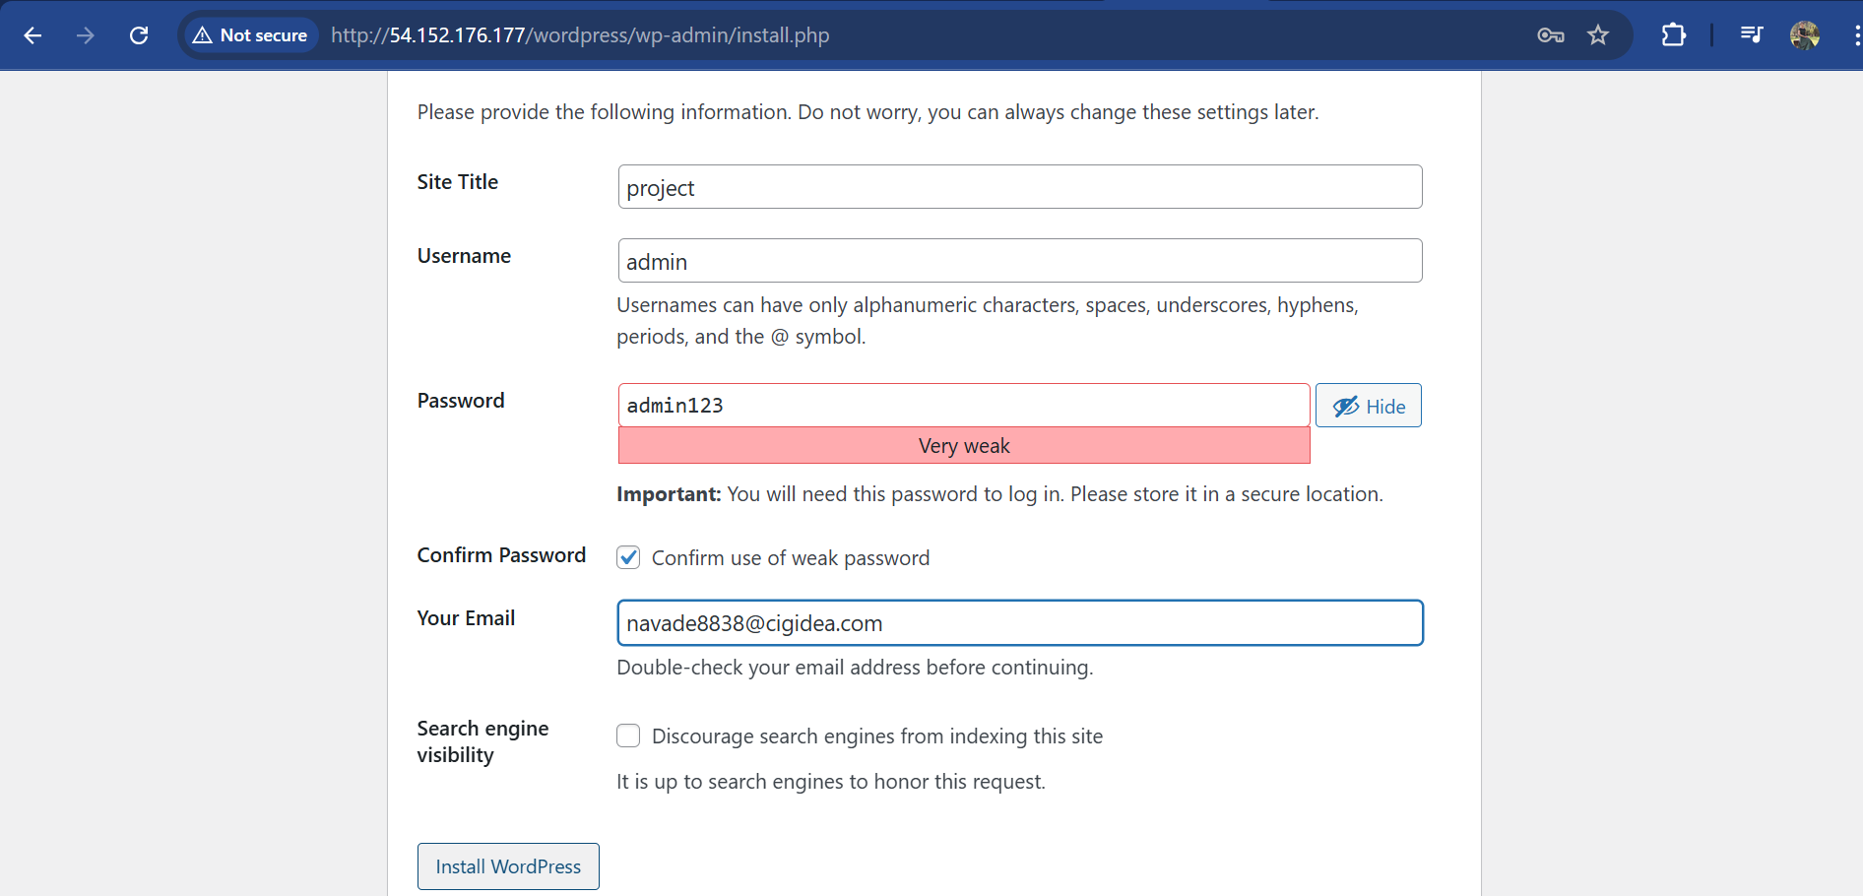

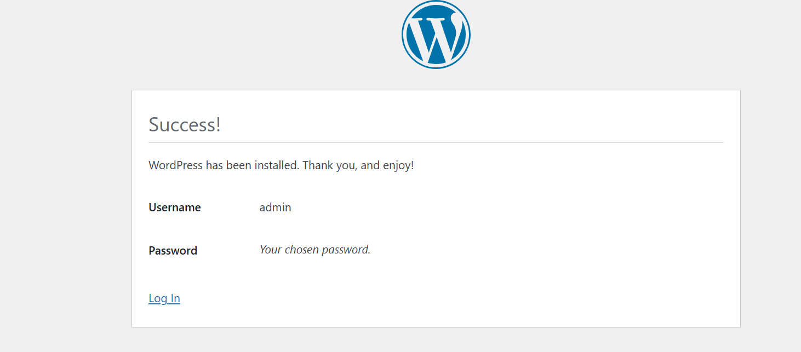

Click the login and provide username and password to login to the wordpress

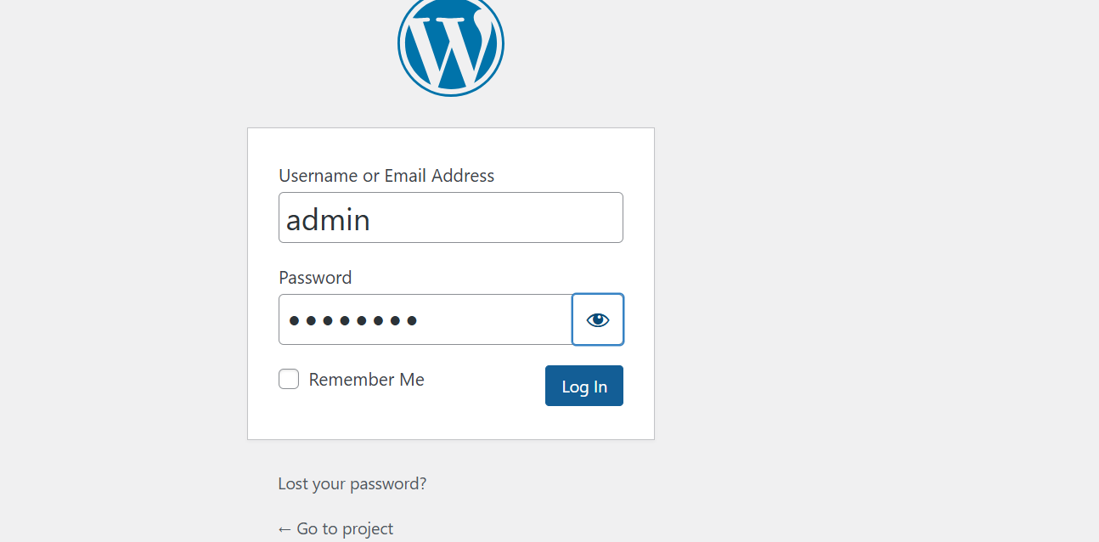

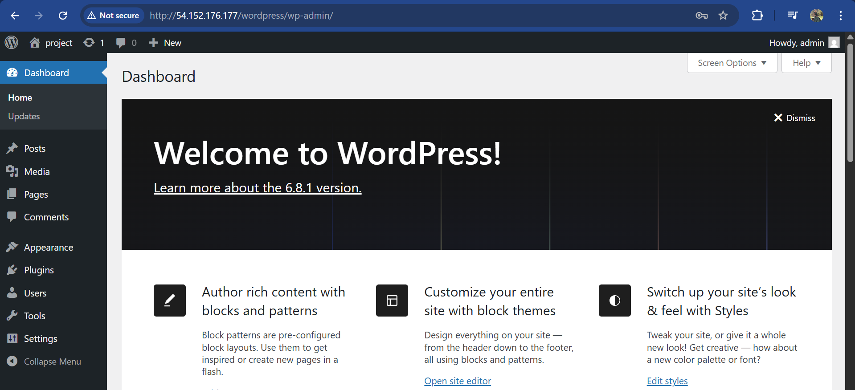

**Step-2 : Launch an AMI from the word press instance created already.**

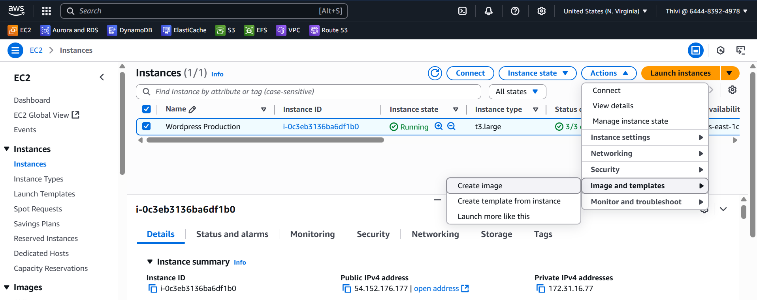

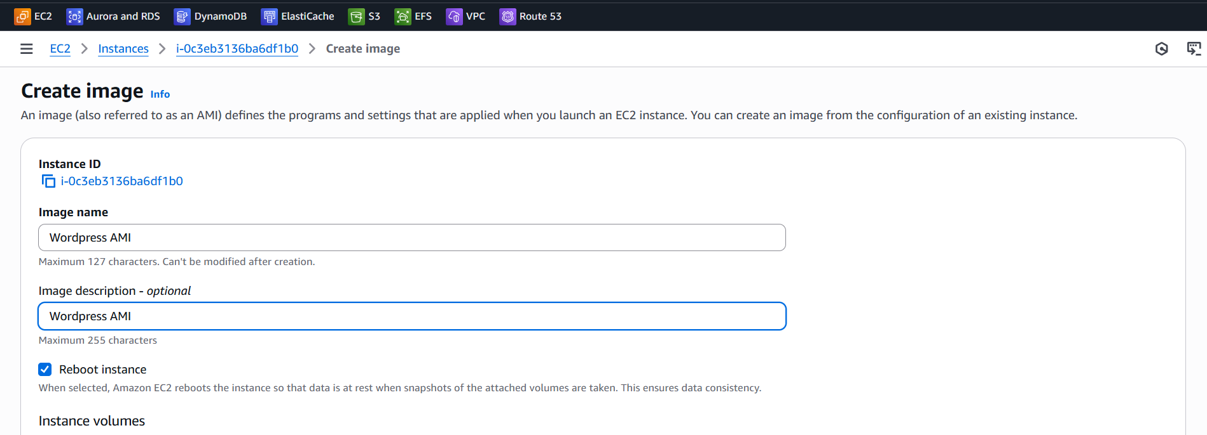

**Now you need to launch an instance from the created wordpress AMI**

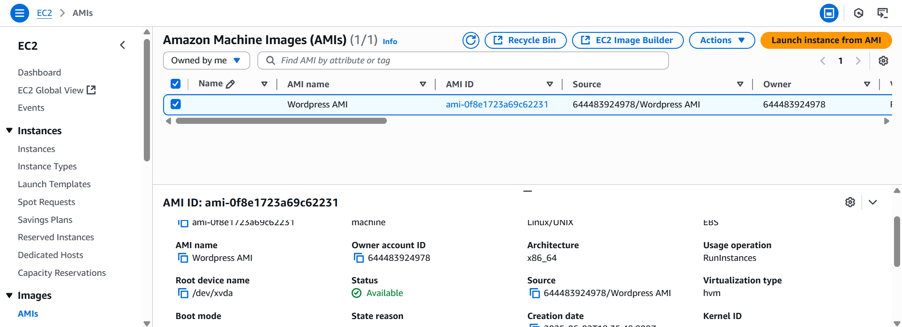

**Create a launch template**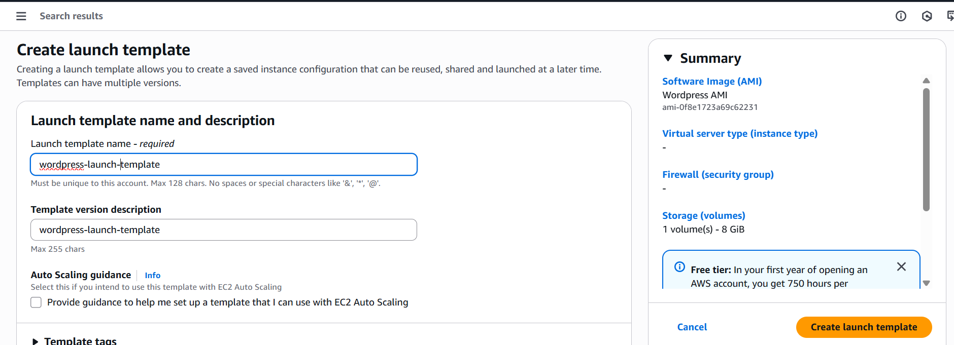

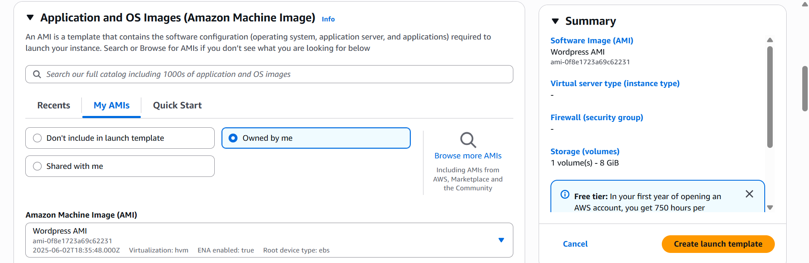

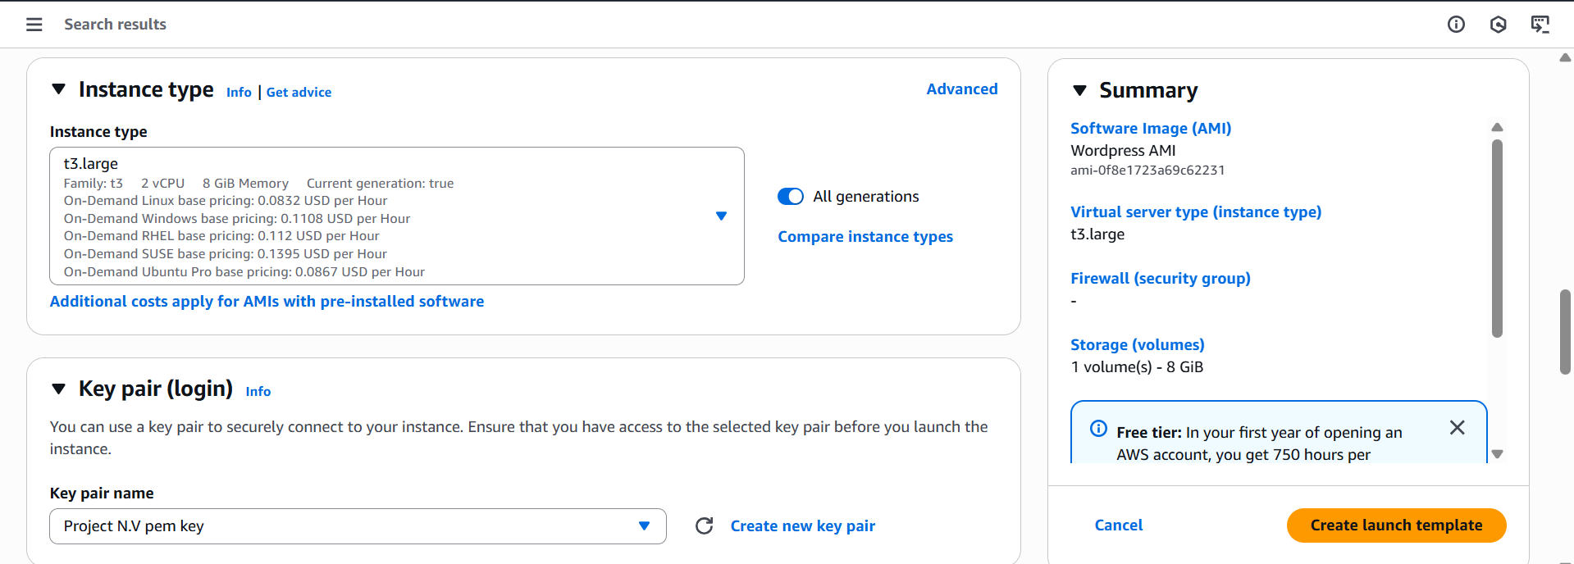

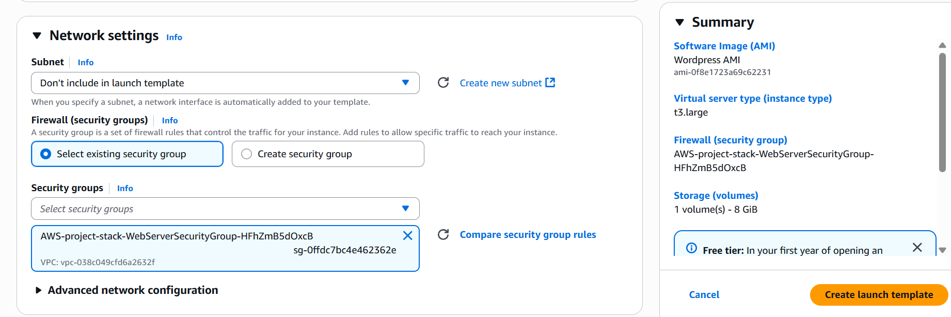

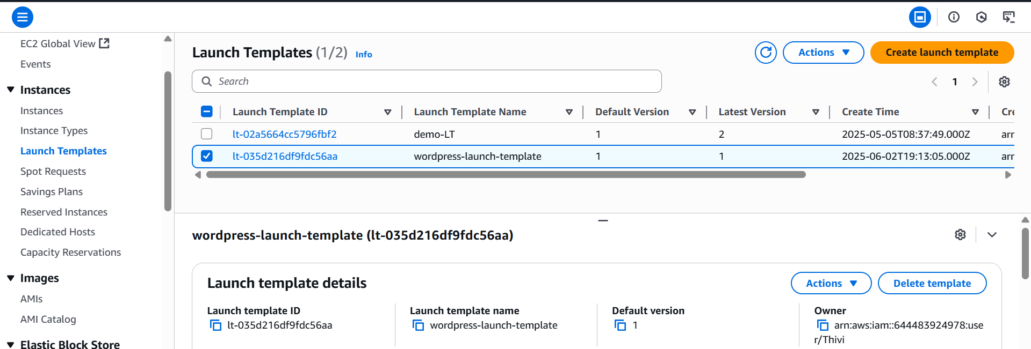

**Create an Auto scaling group (on scheduled actions)**

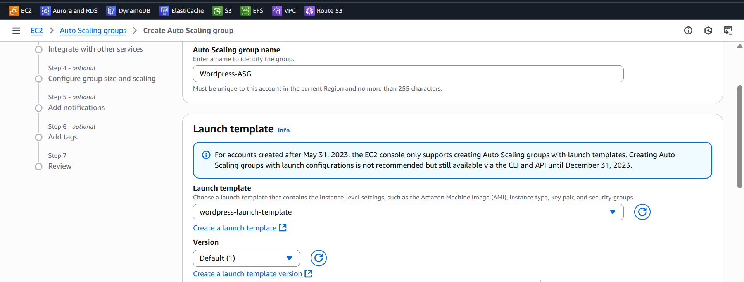

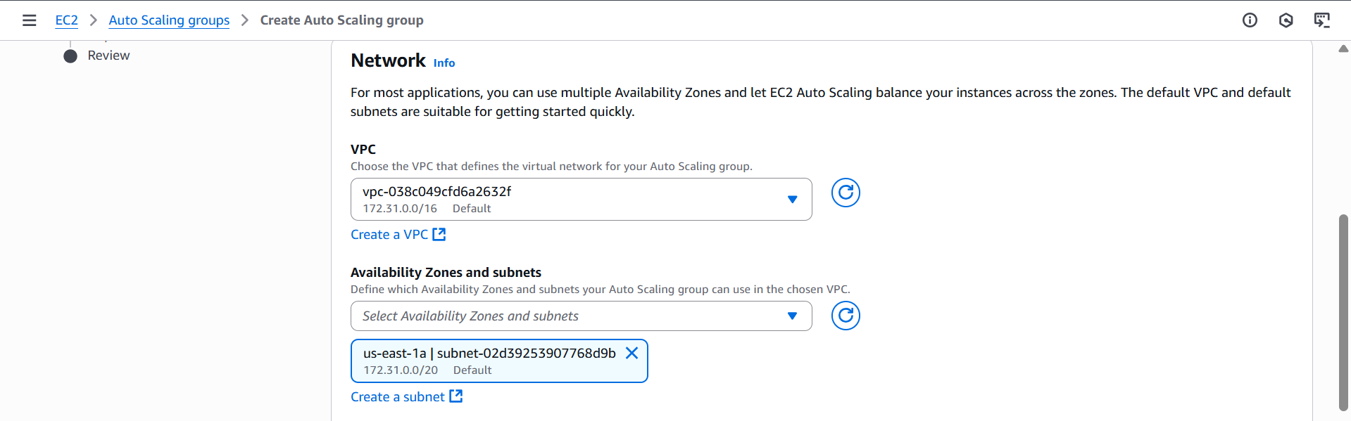

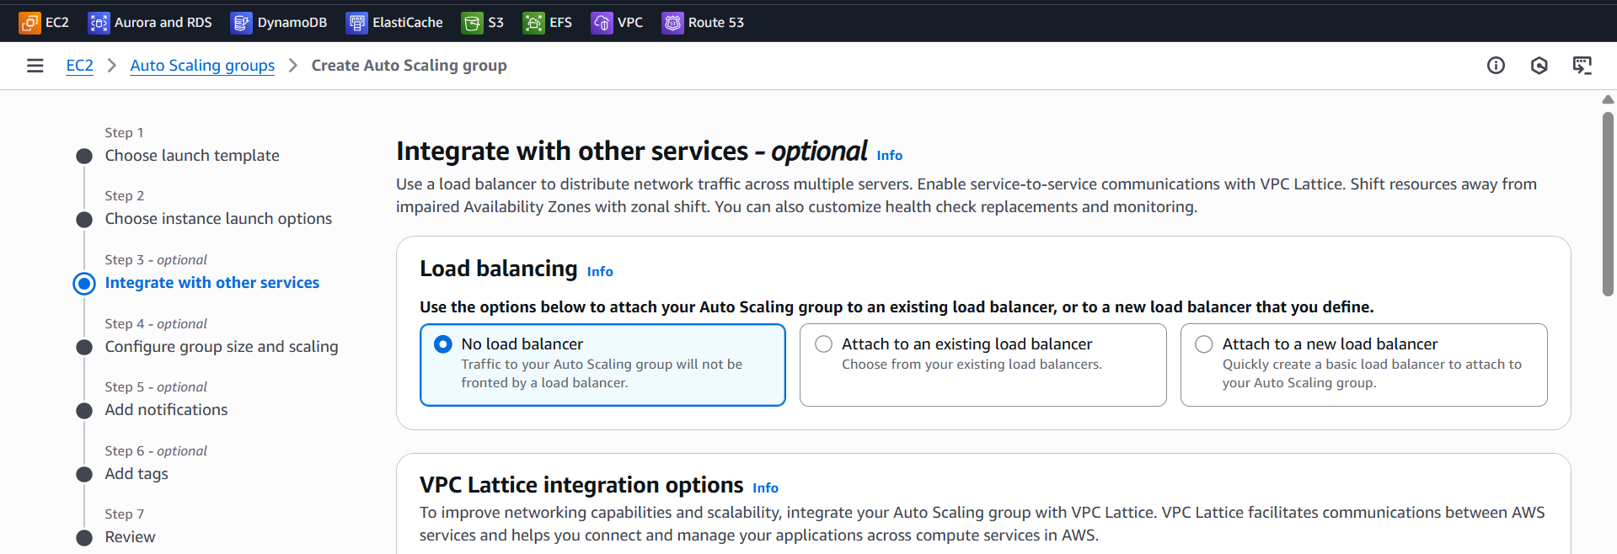

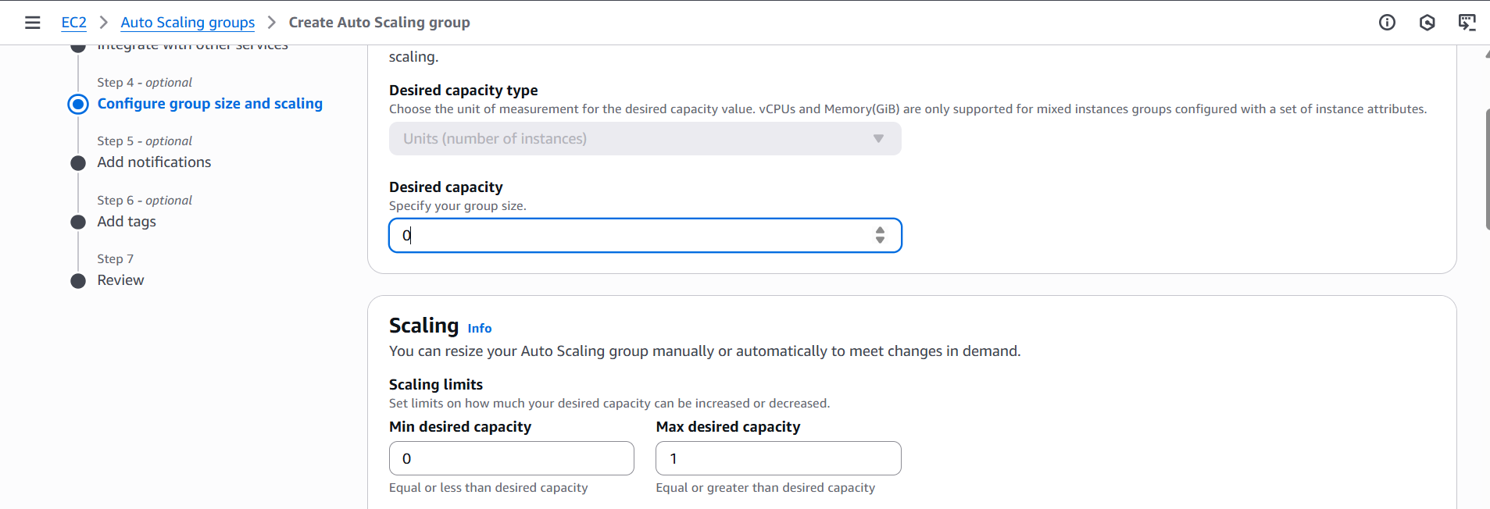

Click create automatic scaling, leaving everything default

Go inside the Autoscaling group created and click automatic scaling.

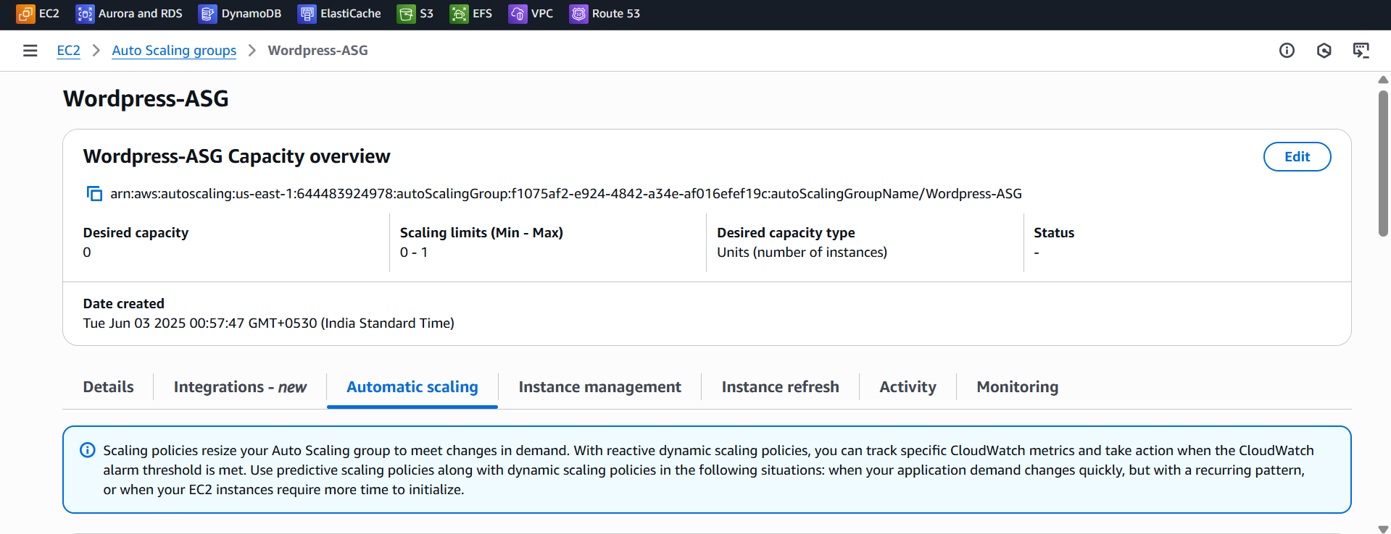

**For testing** purpose, I scheduled the time to my convenience.

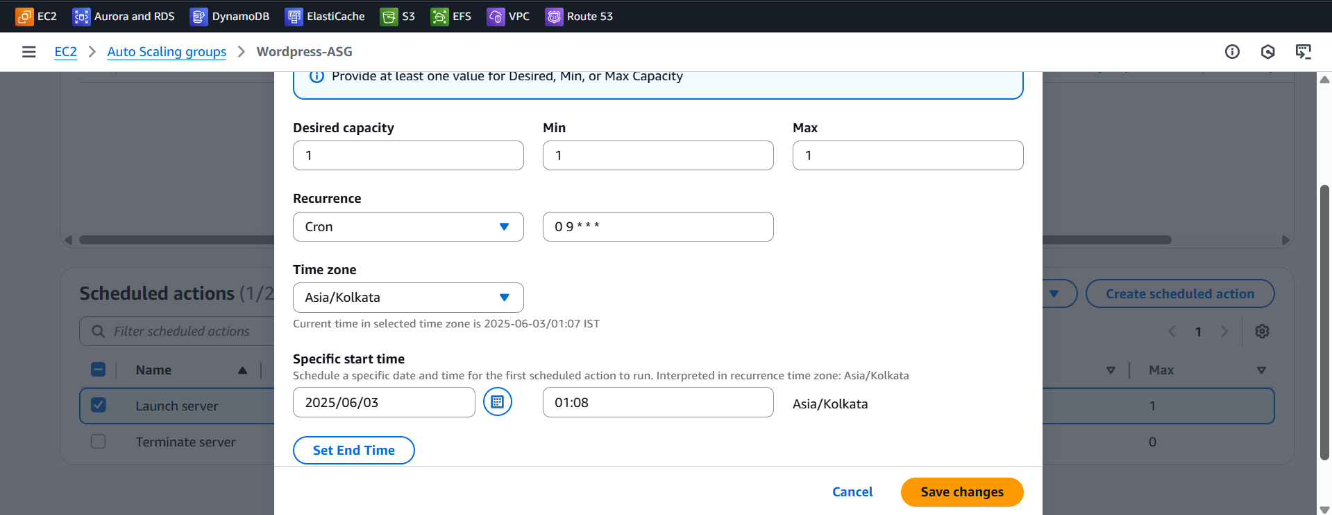

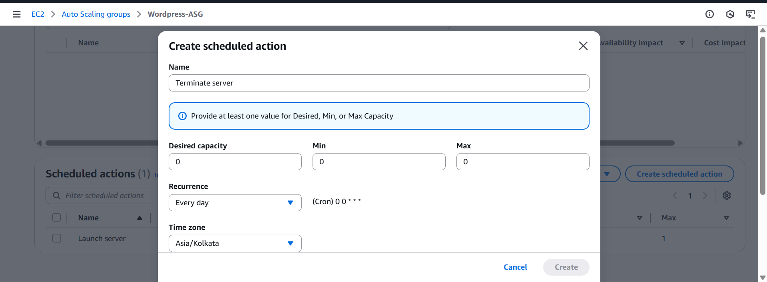

**As per the scheduled action, the instance has been launched.**

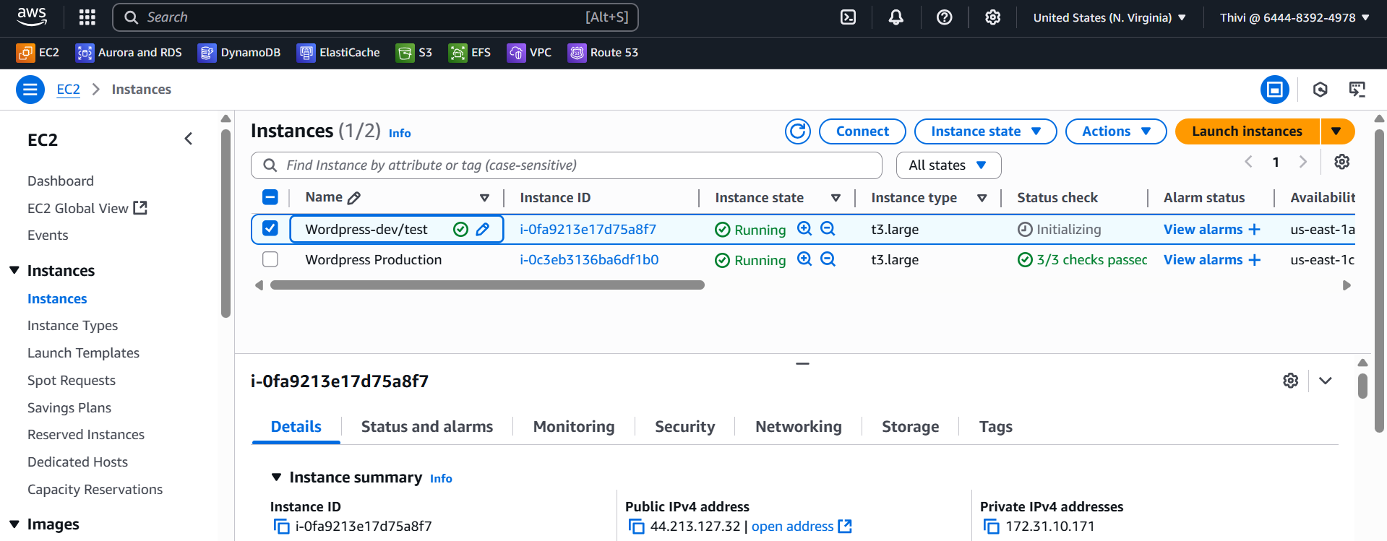

**Copy the public IP/wordpress of newly created dev/test instance and paste it on the browser. You’ll get this output**

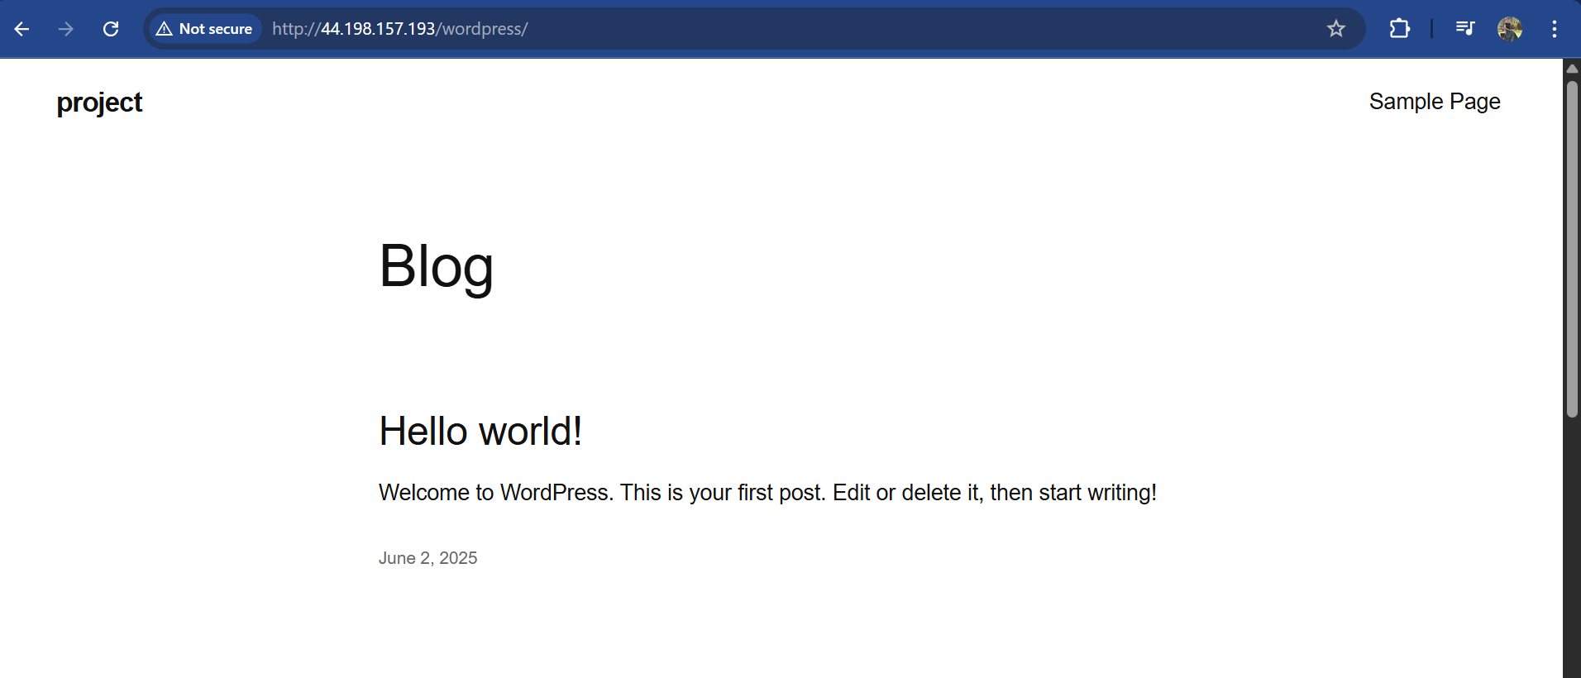

**Now the instance has been terminating**

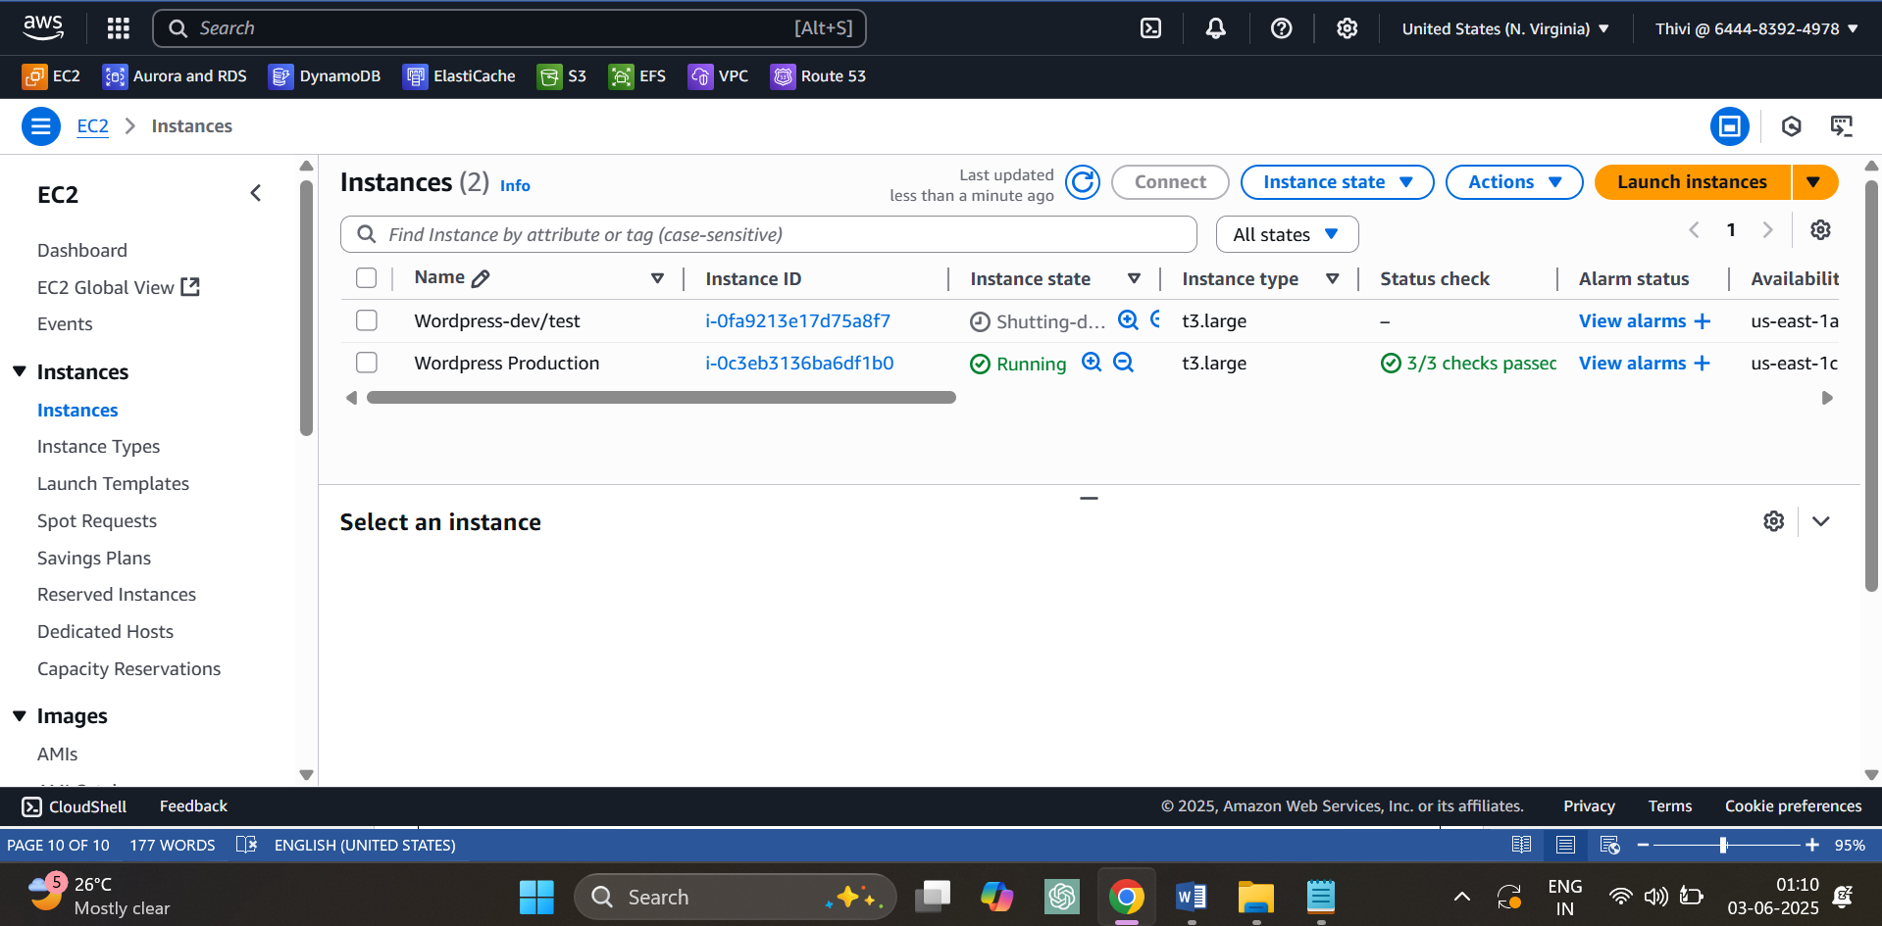

**Now the time has been set according to the project.**

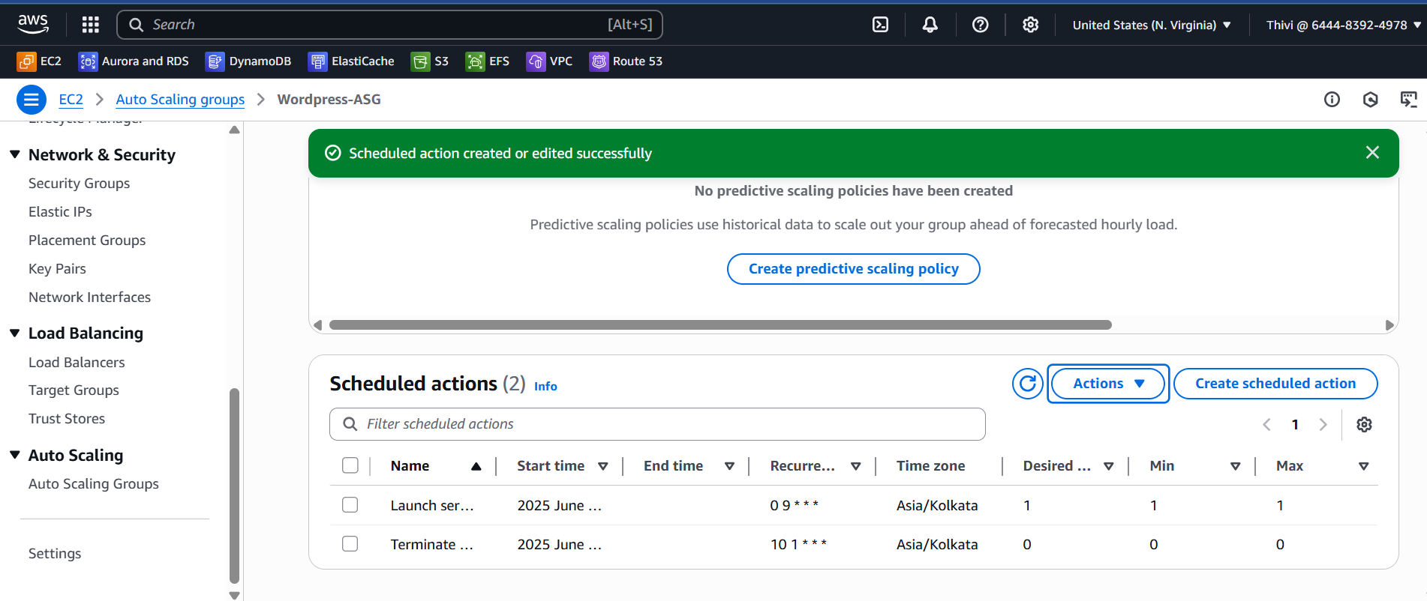

**Monitor the word press production server health check using route 53**

